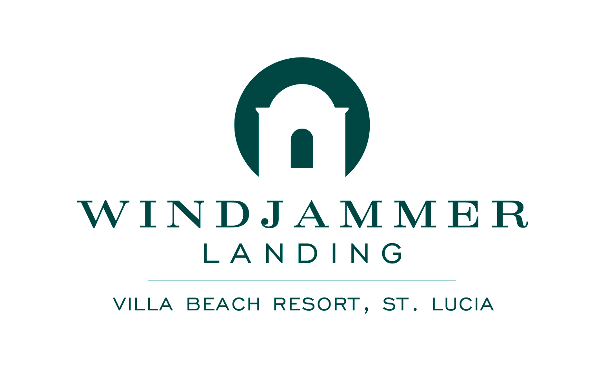

MEDIA CONTACT:
Tin Cans + String
Telephone: 917-593-8476
Gina Iovino
gina@tincansandstring.com

THIS SEPTEMBER, WINDJAMMER LANDING VILLA BEACH RESORT, ST. LUCIA WILL BE OPEN FOR BUSINESS
Packages Available to Book Now For Travel Through the End of the Year

LABRELOTTE BAY, Saint Lucia (May 2018) – The management of Windjammer Landing Villa Beach Resort, St. Lucia announces that the resort will remain open for business this September 2018. In the past, the resort has closed in September for renovations, which were all very well received.

“We are looking forward to welcoming guests this September,” states Scott Seger, managing director of Windjammer Landing Villa Beach Resort. “We have many specials going on during this time, and we hope travelers will take advantage of them to visit the beautiful island of St. Lucia.”

Windjammer Landing has the following specials going on now which are valid for travel this September, including:

Early Booking Bonus – Available on all room categories, receive 35% off any three night stay for room only as well as Windjammer Landing’s all-inclusive package, which includes unlimited a la carte dining at five restaurants, premium drinks at four bars and motorized as well as non-motorized water sports. Bookings must be made 14 days prior during low season, 21 days during high season and 45 days prior to Christmas holiday. Good for travel through December 20, 2019. Some blackout dates apply.

Stay Longer, Save More – Available for booking through June 30, 2018, guests who book three or more nights for travel through September 30, 2018 will receive up to 30% off their stay. Room only and all-inclusive options are available and some blackout dates apply.

Windjammer Landing Villa Beach Resort was designed by Barbadian architect Ian Morrison to look like a Mediterranean village. Brick paths meander through more than 60 acres of lush landscaping, scented gardens, sparkling pools, covered walkways, and hand-painted tiles. Ideal for couples, families, multi-generational travelers, singles and groups, Windjammer Landing is renowned for its welcoming atmosphere, friendly staff, extensive activities, and signature all-inclusive vacation.
The resort offers 353 sleeping rooms among 195 units, including villas, suites and standard hotel accommodations. Many of the villas feature their own private residential-size or plunge pool. Guests can enjoy “Barefoot Luxury” with the perfect balance of culture, health and wellness, entertainment, romance and adventure for vacationers of all ages. As a testament to the resort’s reputation, Windjammer Landing has earned the TripAdvisor® Certificate of Excellence award for the last six consecutive years.

A Windjammer Landing Villa Beach Resort all-inclusive vacation includes all meals and beverages at five al fresco restaurants and four bars; the luxury of six swimming pools; a 24-hour fitness center; both motorized and non-motorized water sports, including waterskiing, snorkeling and windsurfing; complimentary resort-wide Wi-Fi resort; the Jacquot Fun Club, with supervised daily activities for children 4 – 12 years of age; teen activities for kids 13 – 17; a weekly Manager’s Cocktail Party; and the conveniences of a mini-mart and boutique shops.

Room-only packages are also available. All rates vary according to plan, selected accommodations and travel dates.

Windjammer Landing is 32 miles from Hewanorra International Airport (UVF) and five miles from George F L Charles Airport (SLU). Sample flight times from major cities include three-and-a-half hours from Miami, four hours from New York and five hours from Toronto.

For more information or to make reservations, call (877) 522-0722 from the U.S. or Canada. Find Windjammer Landing on Facebook, Instagram and at www.windjammer-landing.com.

About Saint Lucia
One of the Windward Islands of the West Indies’ Lesser Antilles, Saint Lucia is nestled halfway down the Eastern Caribbean archipelago. The “Helen of the West Indies,” Saint Lucia is known for its natural beauty and diverse attractions, including the signature Piton Mountains, tropical rainforests and one of the world’s unique drive-in volcanoes. Culturally rich offerings include the bustling marketplace in the capital of Castries, quaint fishing villages along the coastline, and the annual Saint Lucia Jazz & Arts Festival. Saint Lucia is also home to world-class cruise and yachting facilities.

# # #

